Name of the student: MAYUR PALIWAL
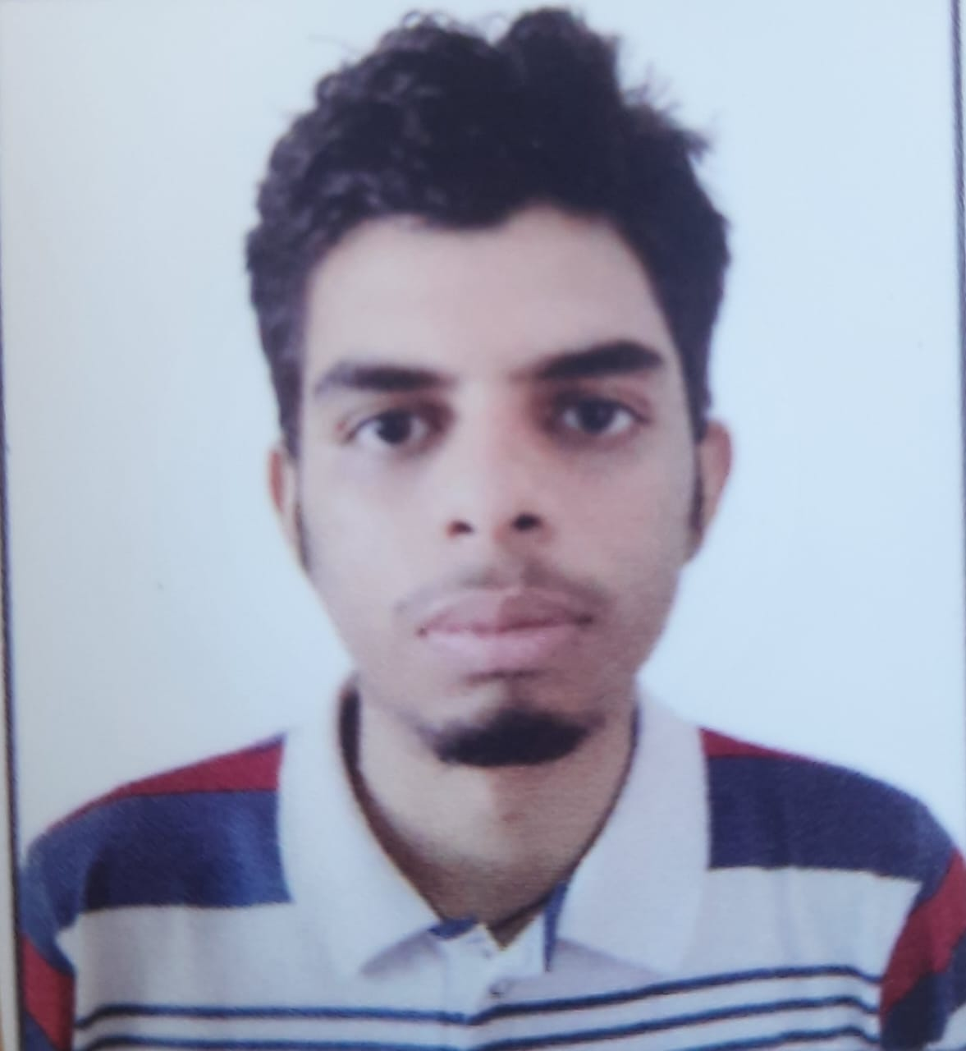
Gender: Male

Marital Status: Unmarried
Date of Birth: 06/12/2001
Mobile No: +91 7974103355
E-mail ID: mayor8863@gmail.com

Permanent residential address :100A, Sneh Nagar Ratlam, M.P,
Pin - 457001

Career Objective: I am a computer science engineering student and looking forward to pursue a good career in the IT industry. My domains of interest are Backend and Fronted Development. I am willing to learn and work to boost up my skills and personality in whichever way possible.

Academics

Branch: Computer Science Engineering (CSE)

Class | Year of Passing | Board / university | Marks Scored / total Marks | Percentage / CGPA | Grade/ Class
SEM 8
SEM 7
SEM 6 | 2022 | Medicaps university |  | 8.58 | A
SEM 5 | 2021 | Medicaps university |  | 9.18 SGPA | A+
SEM 4 | 2021 | Medicaps university |  | 8.96 SGPA | A
SEM 3 | 2020 | Medicaps university |  | 9.13 SGPA | A+
SEM 2 | 2020 | Medicaps university |  | 7.79 SGPA | B+
SEM1 | 2019 | Medicaps university |  | 7.35 SGPA | B+
XII | 2019 | CBSE | 406/500 | 81.2% | A2
X | 2017 | CBSE |  | 8.8 CGPA | A2

# Aggregate Percentage / CGPA: 8.47
# No. of Live Backlogs – 0
# Y.D.: 0

Technical / Domain Skills

Programming Language : C, C++, Python, HTML, CSS ,JavaScript , Nodejs , Angular, Expressjs , TypeScript , Nestjs
- Web server :
- Databases : MongoDb , MySQL
- Operating system : Windows
- Others : Kafka

Projects & Initiatives

Project Title: Personal details API using Nodejs, Expressjs and MongoDB
Description: Made an API which performs CRUD operation in database

Internship /s

- Organization: FiftyFiveTechnologies

Duration: From 11/07/2022 to Present

Position : Software Developer Intern

Description : I am working as Backend Developer Intern performing tasks in NestJs and Kafka.
Made a project connecting api with Kafka Producer in one Project and consuming it another projects making data flow from one project to another using Kafka.

- Organization: TheRapidHire

Duration: From 03/06/2022 to 09/07/2022

Description : I worked as a backend developer build TheRapidHire blog backend using Using Nodejs and MongoDB.

Key Learning: Learned the implementation of backend development, email automation etc.

- Organization: Raise Digital (One Stop AI)

Duration: From 10/06/2021 to 10/08/2021

Description: I worked as a web development intern and worked on a project- “ADVANCED E- COMMERCE WEBSITE” using html, css and JavaScript.

Key Learning: Learned the implementation of front-end web development, web designing and various features of a standard e-commerce website.

Achievements & Awards

1. 3 star at Code-Chef
2. 5 star in C++ at HackerRank

Certifications

Name of Certification | Level Advanced/ Intermediate/ Diploma | Organization | Date of Award
Programming for Everbody | Intermediate | University of MICHIGAN | 19/05/2021

Co Curricular Activities

- Code Chef Medi-Caps Chapter – Executive Competitive Programming
- MUACM Medi-Caps Chapter – Worked as a Technical Member and woked on it’s Website

Interests & Hobbies

1. Football
2. Books
3.Cricket
4. Internet gaming

Declaration

I hereby declare that the above information provided is true to best of my Knowledge and belief.

Date: 02/08/2022 Signature
Place: Indore
